Report YOUR Way


Non-emergency

Online: https://www.met.police.uk/ro/report/

This is the most convenient way to report:

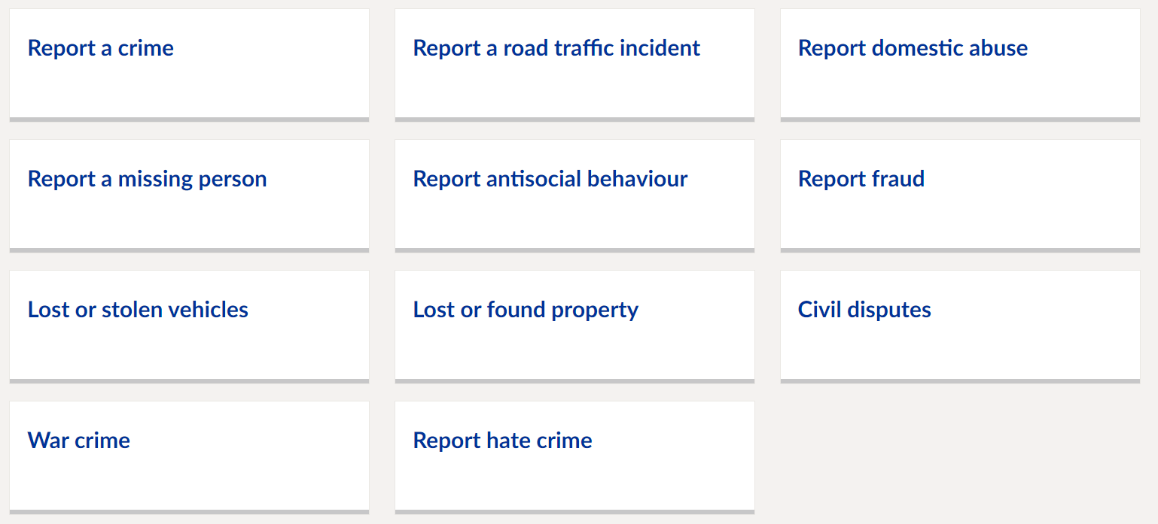

By Phone - 101
Call 101 if you want to report a minor crime or incident, such as:
- a stolen item
- property damage
- a civil dispute
- if you suspect drug use or dealing in your neighbourhood
- to share information about possible criminal activity in your area
- antisocial behaviour
- non-urgent enquiries

There may be a delay in answering your call due to the high volume of calls received at our contact centre.

Emergency

By Phone – 999

Call 999 if:
- a serious offence is in progress or has just happened
- someone is in immediate danger of harm
- property is in danger of being damaged
- a serious disruption to the public is likely
Your call should be answered within ten seconds. A trained member of staff will ask you what happened and where you are. They may ask you if you need any other emergency services, such as an ambulance.
If you have a hearing or speech impairment, use the text phone service on 18000.
How to make silent 999 calls:
999 from a Mobile
If you don't speak or answer questions, press 55 when prompted and your call will be transferred to the police.
Pressing 55 only works on mobiles and doesn't allow the police to track your location.
If you don't press 55 your call will be ended.
999 from a Landline
If you don't speak or answer questions and the operator can only hear background noise, they'll transfer your call to the police.
If you replace the handset, the landline may remain connected for 45 seconds in case you pick it up again.
Calling 999 from a landline automatically gives the police information about your location.

Want to remain Anonymous? No problem. Report crime anonymously to Crimestoppers:

Online - crimestoppers-uk.org

By phone - 0800 555 111
If you want to report a crime, but you don't want to identify yourself, contact Crimestoppers. You can also ask to remain anonymous when contacting Police.
They'll ask questions about the crime but won't ask about you. If you're concerned your call could be traced, dial 141 before 0800 555 111, this will block your phone number. 0800 numbers are free from a landline and don't show up on BT or cable phone bills.

Report fraud and cybercrime to Action Fraud:

Online - actionfraud.police.uk

By phone - 0300 123 2040
If you've been the victim of a fraud, online fraud, cybercrime or you suspect one is being attempted, report it to Action Fraud. Action Fraud is the UKs national fraud and cybercrime reporting centre.

Wandsworth Council

How to report antisocial behaviour:
Antisocial behaviour is unacceptable and can have a negative effect on everyone's quality of life. Antisocial behaviour is defined in The Anti-Social Behaviour, Crime and Policing Act 2014 and Crime and Disorder Act 1998 as:
(a) conduct that has caused, or is likely to cause, harassment, alarm or distress to any person,
(b) conduct capable of causing nuisance or annoyance to a person in relation to that person’s occupation of residential premises, or
(c) conduct capable of causing housing-related nuisance or annoyance to any person.
Antisocial behaviour includes:
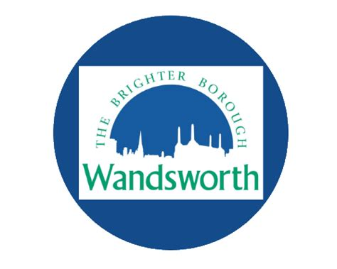
- Threatening and abusive behaviour
- Intimidating groups taking over public spaces
- Vandalism, graffiti and fly-posting
- Dealing and buying drugs on the street
- Dumped rubbish and abandoned cars
- Begging and antisocial drinking
- Misusing fireworks
- Nuisance neighbours
https://wandsworth.gov.uk/community-safety/antisocial-behaviour/how-to-report-antisocial-behaviour/

Your safer neighbourhood team contact information:
St MARY’S SNT: StMary@met.police.uk or call us on 0208 247 8604



@MPSNorthcote @WandsworthPolice
Please note these contact details are not for crime reporting.

