Protect your bike from theft
If you’ve ever had your bicycle stolen, you’ll know how upsetting it can be. Our practical tips will help keep your bike safe and out of the hands of thieves – and also advise on how to get it back if it is stolen.
The most important thing to remember is, double lock your bike and register the frame number.
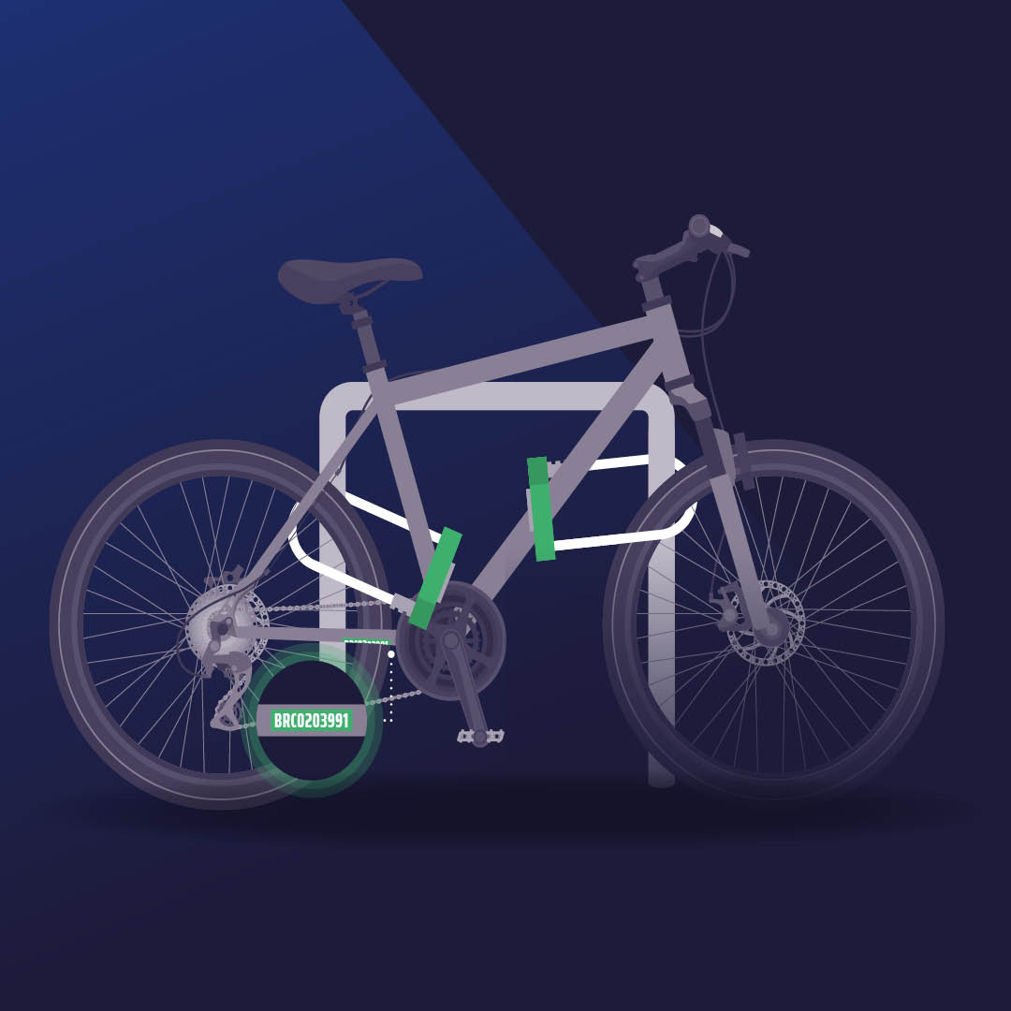

Ten ways to protect your bike
Follow these 10 tips to ensure your bike remains safe, secure and not a statistic.

1. Double lock it
Using two locks slows thieves down and makes your bike less of a target. Use two quality locks, at least one of which is a D-lock. Thieves are less likely to carry multiple tools, so use two different types of lock if possible.

2. Lock the lot
Lock the frame and both wheels to a secure cycle stand.

3. Secure it
Secure your bike as close to the stand as possible to give any thieves little or no room to manoeuvre.

4. Take removable parts with you
Take parts that are easy to remove with you, such as wheels, lights, baskets or the saddle. Or use locking skewers or nuts which can increase security by securing the bike's components to the frame permanently.

5. Park securely
Lock your bike at recognised secure cycle parking. It should be well lit and covered by CCTV.

6. Register it
Register your frame number on a national bike registration database approved by Secured by Design. The frame number is usually found underneath the bike between the pedals or where the back wheel slots in. If your bike is ever stolen and recovered by the police, it can be traced back to you.

7. Mark it
Get your bike security marked. It’s a highly effective, visible deterrent to bike thieves. They know that if they are caught with a registered bike, the owner can be traced and they will be arrested. Security marking products can be found at Secured by Design.

8. Remember safety begins at home
Take the same care to lock your bike securely at home as you would on the street. Avoid advertising that you have a bike at home, for example, by removing car roof racks, and creating ‘privacy zones’ on apps like Strava to avoid disclosing your location.

9. Check ownership
Ask for proof of ownership and check the bike frame number on national bike registration databases approved by Secured by Design.

10. Act fast
If your bike has been stolen, contact us as soon as possible by calling 101 or reporting online. Give us your frame number, cycle database number, a photo and any other details and make sure you update the status on the cycle database where you registered it. The sooner we know, the sooner we can act, which might stop it being sold on.

What to do if your bike is stolen
There are various courses of action open to you if your bike goes missing. Whichever you take, make sure you do it as soon as possible. Time really is of the essence.
Stolen Bikes in the UK will help to spread the word on the theft of your bike and offer you advice to help get it back.
Find that bike lists adverts for bikes placed on online marketplaces, which you can check frequently to see if yours has been listed for sale.
Adverts are usually placed within 24 hours of the theft but if not, keep looking as they sometimes take a few months to pop up.
It might also be worth visiting and posting on the following forums:
- Ride.cc Bike Forum
- Bikeradar
- CycleChat
London Fixed Gear and Single-Speed is a forum specific to the capital.

