Keep it safe
If you have high value items such as jewellery, watches, passports, credit cards, computer data and identification documents, you may want to consider storing them in a safe.
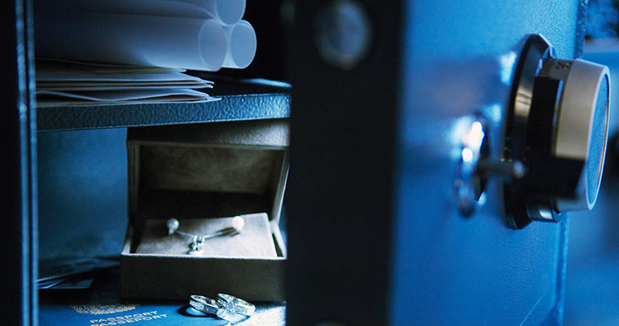
If you have high value items such as jewellery, watches, passports, credit cards, computer data and identification documents, you may want to consider storing them in a safe.
There are two options – either a home safe or a safety deposit vault.
Should you opt for a safe in your home, ensure it is fire rated. Home safes are also insurance rated according to the type and value of items designed to be placed inside, so check with your insurance company first to ensure you are adequately covered.
Position the safe carefully so it won't be easily discovered.
Don't place it in your bedroom as this is the first place a burglar will look. Be sure to effectively secure your safe by bolting it to a wall or floor. For more information on safes, see www.securedbydesign.com.
If you have a large amount of family gold or jewellery, you may want to consider using a safety deposit vault. This has the advantage of removing the risk of storing valuables in your own home and can also make your home less of a target to burglars.
Contact your insurance company should you opt for this, as it may impact on your current policy and premium. The National Pawnbrokers Association can provide more information about safety deposit vaults in your area.

Mark your property to deter burglars
A determined burglar can be difficult to discourage. Naturally, top-notch security in the form of good quality doors, windows, locks and the like are excellent deterrents but there’s even more you can do to stop burglars in their tracks.

Mark it
Make your valuables less attractive to thieves by using a property or police approved forensic marking solution only visible under Ultraviolet (UV) light. This can take the form of a special marker using ink or paint. Mark or etch your property with your postcode, house or flat number or the first three letters of your address. All of these measures help police identify stolen goods, making it harder for thieves to sell. So make your mark.
And property marking isn’t only for things like electrical items and bikes, you can also mark high value belongings like antiques. However, we recommend that you seek specialist advice.

MetTrace
The Met Police have been rolling out MetTrace to help residents make their homes more secure by providing crime prevention advice and free SmartWater® property forensic marking kits to 1 in 7 London homes. For more information and to find out if you’re eligible for a free pack, or other ways to get SmartWater, visit our MetTrace page.

Record it
Register your valuables free of charge using one of the accredited property databases such as Immobilise.
Take photographs and keep documents like receipts related to your property so you can prove ownership.

Register your bike
If you value your bike, then register it with Bikeregister.com. The prominent stamp acts as a great deterrent.

Flag it
If you value it, then mark it as protected. Window stickers and signage are extremely effective and are proven to be a powerful deterrent against burglary.

Join your Neighbourhood Watch
By becoming part of your local Neighbourhood Watch, you’ll be joining other likeminded neighbours who, by keeping their eyes and ears open, help to keep potential criminals out of the area.

Control access to all areas
Your home is only as secure as its weakest point of entry. That’s why it’s so important to have doors and windows that are as secure as possible. Here is where you’ll find lots of helpful advice on how to keep potential burglars out.

Double secure
Simply shutting the door won’t prevent burglaries. Double-lock the door every single time you leave the house.
Modern multi-locking and uPVC doors use a system of hooks and latches to secure the door but these only work if you lift up the handle and then remember to turn and remove the key. Remember – lift, lock and remove.
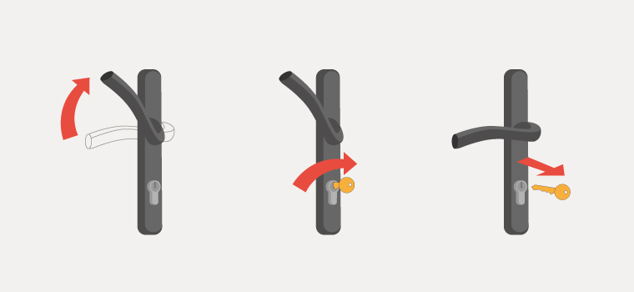Lift, lock, remove

Doors and windows
Controlling access to your home starts with securing doors and windows. To see how your home compares and to get more advice with our top tips, visit our pages on Control access with doors you can trust and Prevent access through your windows.

Control access with doors you can trust
Your door is the gateway to your home. As such, you want it to be as solid and protective as can be. Which means it being strong enough to withstand even the most determined burglar.
Whether you live in a flat or a house, your front door will always tell a thief the levels of security surrounding your home. If it looks really secure and burglar-resistant, then they’ll think twice about trying to gain entry.
A locksmith belonging to the Master Locksmiths Association will check to see if your door is secure and made of solid timber or a robust composite. The locksmith can also reinforce the frame and check if the locks and hinges are British Standard approved.
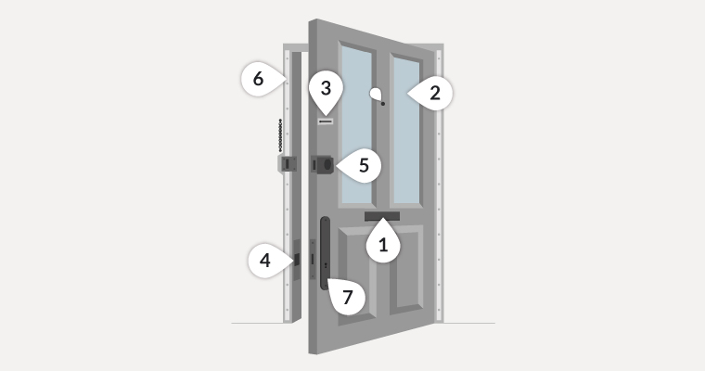
1. If your door has a letterbox, a guard fitted to the rear of the door will prevent someone reaching in with a stick and a hook to fish for any nearby items such as a handbag or keys – which should never be kept near exterior doors. Consider cat flaps and dog flaps too.
2. Windows can be reinforced by using special film or by installing laminated panels.
3. Spy holes and security chains are recommended so that anyone visiting can be identified before you open the door.
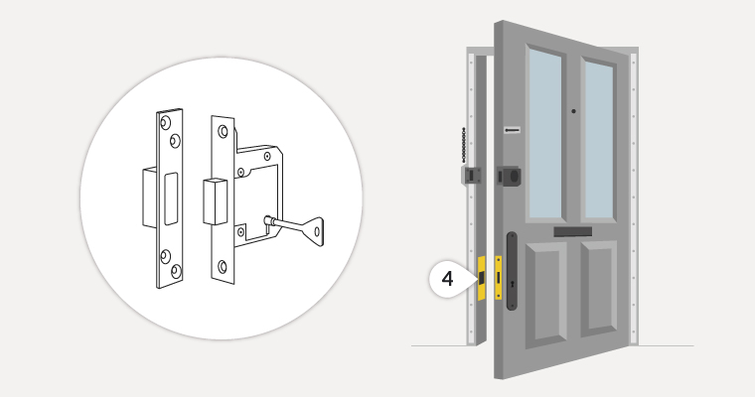
4. Always remember to use both locks and check to make sure that the mortice lock is double-locked every time you leave your home.
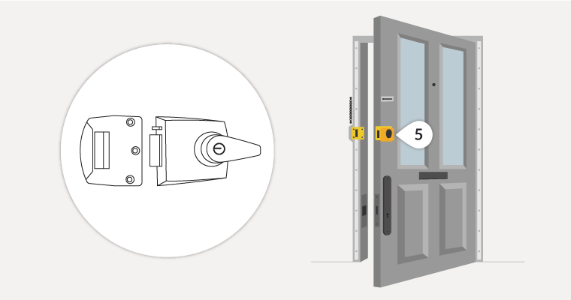
5. A simple turn of a double-locking nightlatch gives you added security and peace of mind.
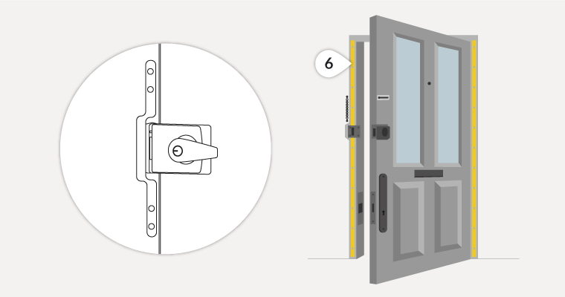
6. Door bars, such as a London Bar or Birmingham Bar greatly reinforce the doorframe and provide excellent protection against anyone trying to force a door open or kicking it down.
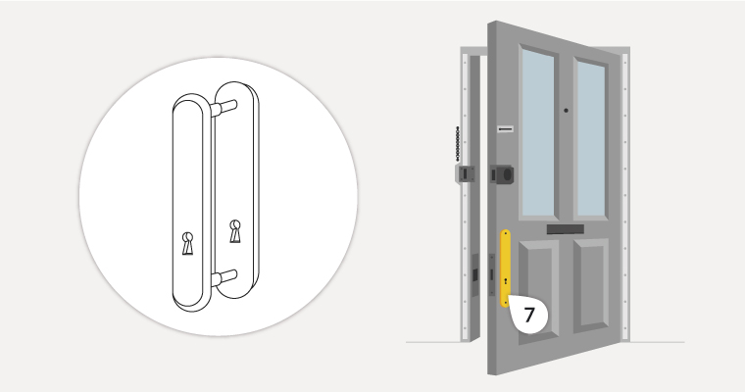
7. A lockguard does exactly that; it protects the keyhole and lock from being tampered with and is a great deterrent.
If you are putting in a new front door, always fit security accredited products as these are tested to British standards and approved by the insurance industry. Talk to your locksmith about standard PAS 24 2016.

Patio doors
Sliding patio doors are vulnerable to forced entry, so do check that yours have an anti-lift device fitted so they can’t be lifted out of the frame.
Some uPVC doors are fitted with locks that protrude from the frame on the outside (euro profile locks for those in the know). If yours do, then consider getting a Master Locksmiths Association member to change the lock to a shorter one that can't be snapped off.

Prevent access through your windows
Burglars tend to target windows as they generally offer easier access than doors. Take a good look at your windows from the outside and remove any potential access points where possible. Are there any walls, bins or garden furniture that could be used to reach windows? Don’t give thieves a leg-up, and for windows that are within reaching distance such as ground floors, see our tips below.
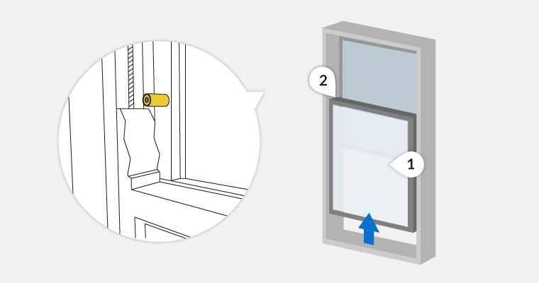
1. Laminated glass or security film is recommended for ground floor and accessible windows.
2. Sash stops prevent anyone opening the sash window enough to climb through.
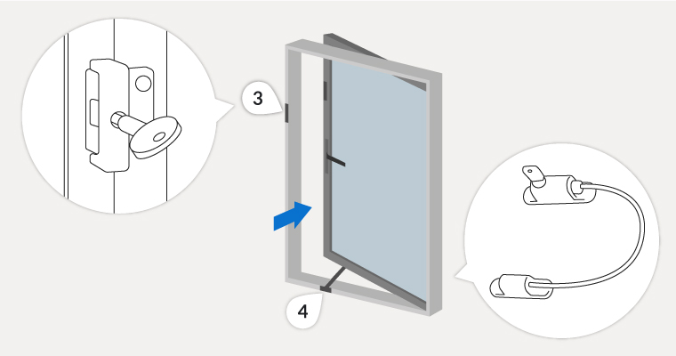
3. Key operated locks are recommended for window types that open out, rather than up, and any ground floor or accessible windows. Remember, window locks are only effective if used, so check that you have locked them before you leave home or go to bed.
4. Window opening restrictors allow you to ventilate your home but make sure they can’t be picked and unlocked from outside.
If you’re replacing your windows, always consider a security accredited product as these windows are tested to British standards and are insurance approved. A good standard is PAS 24 2016.

How safe is your flat?
Although there are fewer points of entry to a flat, they need to be as well protected as possible. As for overall building security, all residents need to keep an eye and an ear out as well as making sure that communal front and back doors are never left open.

Boundary
Protection of a flat begins from the outside. Check that the managing agent or landlord cuts shrubs and planting back regularly so that they don’t obscure anyone from view or interfere with lighting or CCTV.
If you notice something’s not working properly or if a light is out, let the managing agent or landlord know so that it can be fixed straight away.

Outbuildings
Keep cycle stores, bin stores, sheds and other covered areas locked and secured. These hidden spaces can attract loitering and lead to antisocial behaviour, especially after dark.

Communal door
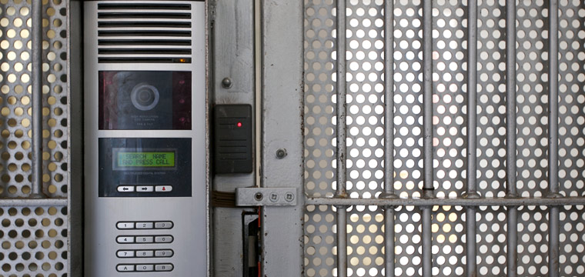
Your communal door is only effective if it is closed and secure, so always remember to check that it locks behind you. If it doesn’t, then report it to your management agent or landlord so it can be repaired quickly.
Don’t ever buzz anyone in that you don’t know – even if they say that they’re expected by another resident – or let them follow you in.
The best communal door entry system as recommended by the police is an audio and video entry system where residents can see and talk to a visitor before they let them in.
The ideal communal door will be robust, security accredited and fitted with a good self-closing arm and two magnetic locks top and bottom. It should also be linked to the fire alarm and an electronic access control system operated by a key fob.
Communal doors should automatically open and remain so in the event of a fire but be fitted buttons or handles that allow you to manually override if needed.

Key fobs
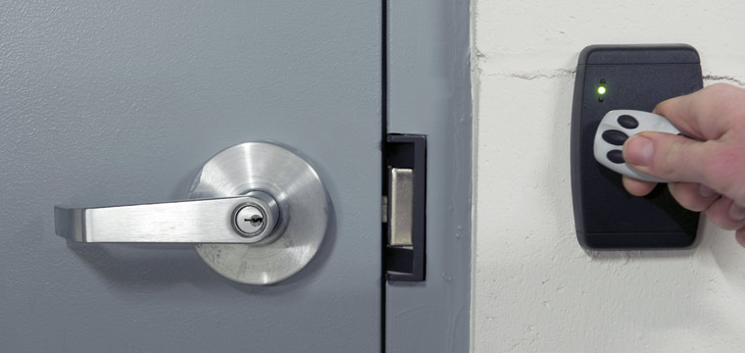
For even tighter security on communal entrances in blocks of flats, it’s always a great idea to have personalised security key fobs that can track who is leaving and entering the property.
With all multiple occupancy buildings, you never know who’s coming and going. And that’s why it’s advisable to get together and get a key fob for front and rear doors to the building. You can share the expense or, if properties are rented, then approach the landlord, explaining the benefit to them.

The way fobs work
Each flat has its own keys plus one or two security key fobs for common entrances – dependent on the number of occupants. If someone loses theirs, then they must pay, say, £10 or £20 for a replacement.
The added benefit, apart from closer scrutiny of visitors to the building, is that there’s no fumbling to get keys in a lock while on the doorstep.

Common areas
Consider where the post boxes are located as these are often targeted by criminals. Ideally, they should be in a secure lobby area and be lockable so that no one can easily fish out mail.

Your flat doors and windows
For tips on how to secure the front door of your flat, please see our detailed advice on door security.
If you live on the ground floor, ensure that your windows are closed and locked every time you leave your flat. And we advise you to consider an accredited burglar alarm system. For more on keeping your windows secure, read our detailed advice on windows.

Leaving your home checklist
Whenever you go out, it’s important to leave your home secure. Getting into an ‘exit routine’ can help ensure that you don’t forget obvious, but important things, like not leaving your valuables near windows, or no lights on if it will be dark before you get home. Here’s our quick reminder on what to do just before you go out.

Become a creature of habit
Try to get into the habit of following your own course of action when you lock up your home. This will ensure that you don’t forget anything.
Here’s what we recommend you do before you go out:
- close and lock all your doors and windows, even if you’re only going out for a few minutes
- double-lock any door
- make sure that any valuables are out of sight
- keep handbags away from the letterbox or cat flap and hide all keys including car keys, as a thief could hook keys or valuables through even a small opening
- never leave car documents or ID in obvious places such as kitchens or hallways
- in the evening, shut the curtains and leave lights on
- if you’re out all day, then it’s advisable to use a timer device to automatically turn lights and a radio on at night
- set your burglar alarm
- make sure the side gate is locked
- lock your shed or garage
- lock your bike inside a secure shed or garage, to a robust fitting bolted to the ground or wall, like a ground anchor

Going away?
Here are five tips to help you keep your home and belongings stay safe while you’re away:
- if you’re off on holiday and wish to post anything on social media, make sure your posts aren’t public and that they’re only seen by your friends
- leave lights and a radio on a timer to make the property appear occupied
- get a trusted neighbour to keep an eye on your property or join a Neighbourhood or resident Watch Scheme
- consider asking your neighbours to close curtains after dark and to park on your drive
- remember to cancel newspaper and milk deliveries

Protect your home by protecting your garden
Protecting your garden and outbuildings not only keeps bikes and other valuables in your shed safe, but can also stop burglars getting into your home.
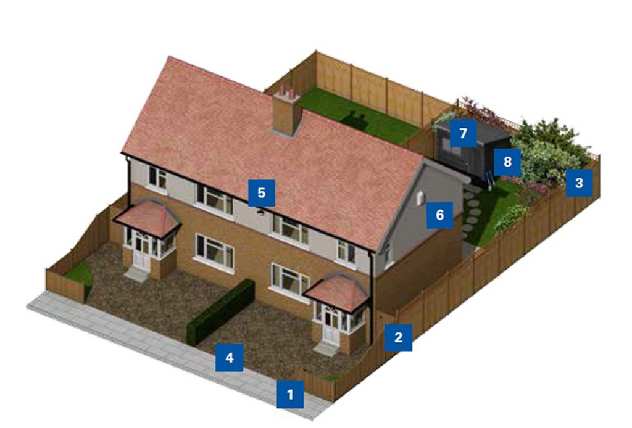
- Low front boundary; keep hedges and walls at the front of your house low (under one metre) so burglars have nowhere to hide.
- Secure side gate; keep side gates locked at all times. Open gates mean burglars can easily access your home without being seen by passers-by or neighbours.
- High side and rear boundaries with trellis and spiky defensive planting; keep hedges, walls and fences around your back garden high (over 1.8 metres). Add lightweight trellis to gates and fences and plant some prickly plants to make it harder for burglars to climb over.
- Gravel driveway and path; gravel driveways and paths make it harder for burglars to go undetected.
- Security light; install an outside security light so that intruders can’t approach without being seen.
- Intruder alarm system; install a burglar alarm system.
- Secure shed door and window; always keep your shed locked and secured. Often sheds contain valuables such as power tools and bicycles.
- Never leave tools lying around; never leave tools lying around as they can be used as a way of breaking into your home.

Stay secure in summer
Leaving ground floor windows, doors and patio doors open in the summer can give burglars the perfect opportunity. If you’re upstairs or out of the room, even just for a few minutes, close them and help shut burglars out.

Extra steps you can take
Consider buying a shed alarm. These are usually quite cheap but still effective.
Add an extra layer of protection to shed windows with laminate sheets of film or internal metal grills.

Create a natural defence against burglary
Planting particular shrubs (in their mature or semi mature form) along garden walls and fences can make it harder for burglars to access your property or put them off completely. To maximise this effect plant them close to each other.
We recommend planting any of the following:
- Berberis
- Osmanthus
- Forget
- Poncirus
- Crataegus
- Pyracantha
- Aralia
- Chaenomeles
- Ribes
- Oplopanax
- Eleagnus
- Robinia
- Colletia
- Ilex
- Climbing roses
- Maclura
- Mahonia
- Ligustrum (privet), or laurel
- Smilax and Xanthoxylum

Live in a ground floor flat or share a communal garden?
You can still make use of these tips by planting in front of ground floor windows to prevent easy access.

Give burglars nowhere to hide
Burglars don’t want to be seen or heard and if they think they’ll be noticed by a neighbour or passer-by, then they’re likely to feel exposed and identifiable, which will probably make them move on. Here are some useful pieces of advice on helping to keep burglars out by giving them no hiding place.

Keep it visible
You’d think that it would be best to make a property less visible from the street, and to keep it hidden from prying eyes behind overgrown bushes, trees, high fences or walls. In reality, all that this serves to do is make it easier for a burglar to get close to a home unnoticed, and provide somewhere to hide while carrying out a burglary or theft from the property.
- 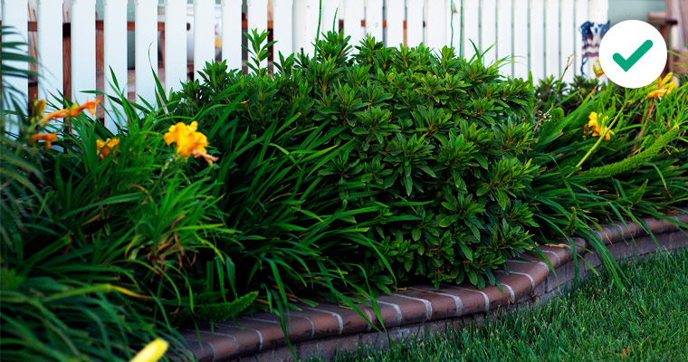
- 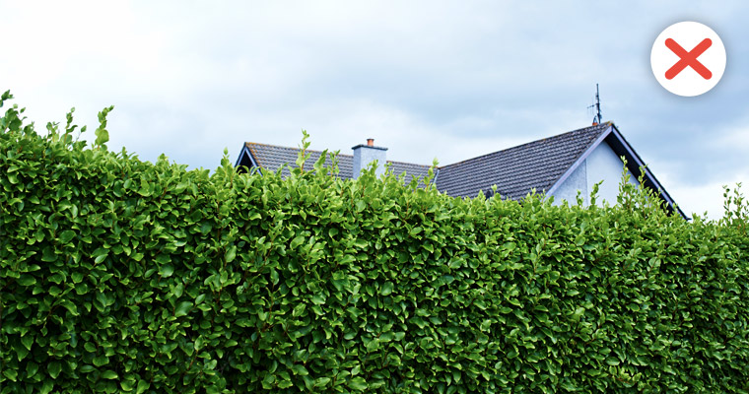
- 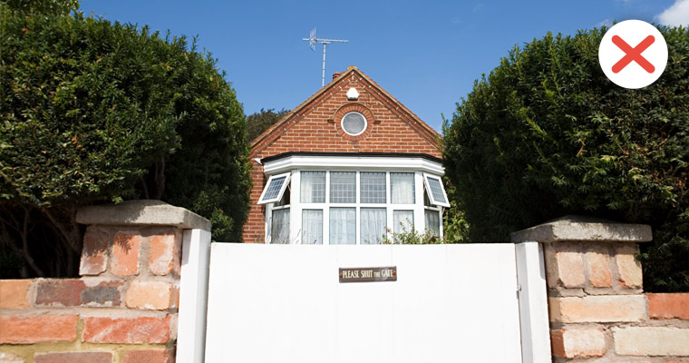
- 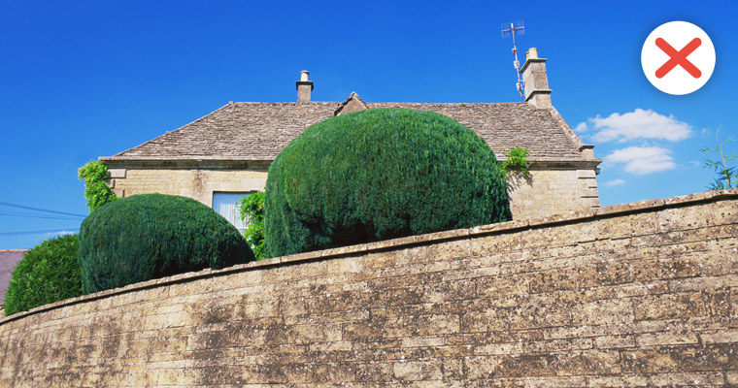
- 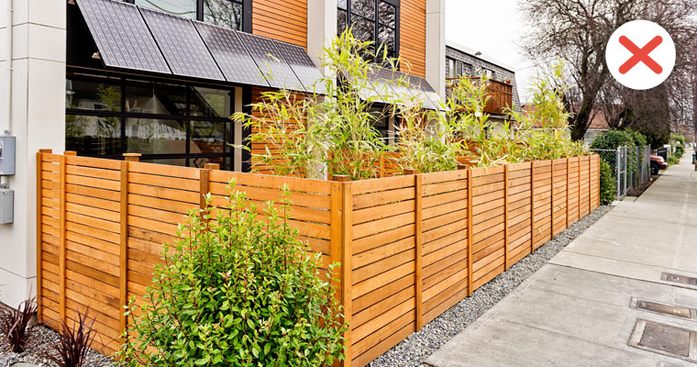
- 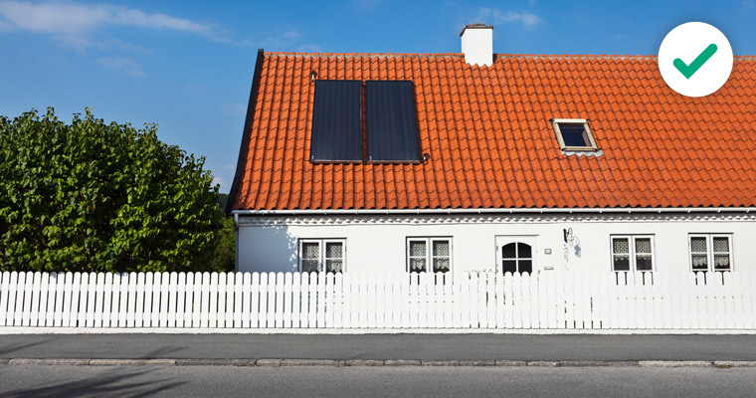
- Lower fences at the front around one-metre high are preferable to high fences as they allow for a clear view over the top and don’t provide cover for anyone wishing to hide.
- At the rear and sides, taller fencing is recommended to prevent easy access.
- Trellis, thorny plants, or a suitable anti-climb topping such as plastic spikes make it difficult for anyone climbing over a fence or gate.
- Planting prickly or barbed shrubbery along boundaries and fence lines acts as an effective natural barrier.
- Gravel driveways and paths will make sure you hear anyone approach.
For more information on creating a boundary, visit our advice on criminal damage.

Other ways to make it difficult for burglars

CCTV
By using well-defined boundaries as a basis, CCTV can be a valuable tool. However, it doesn’t prevent a crime from being committed and does have limitations.
CCTV linked to a smartphone will alert you to someone crossing your boundary.
Most importantly, CCTV is no substitute for good quality physical security such as secure doors and windows.
Some cameras work by day and by night, and record when they detect movement. Some can be remotely viewed from a smartphone.
Position cameras where they are best able to obtain good quality facial images. Could you recognise or identify someone from the footage?
There is legislation for home CCTV use, so always seek advice from an accredited installer first to ensure your system complies with the law.
Place signage up warning that CCTV is in use.
For advice and approved suppliers of CCTV visit the National Security Inspectorate and the Security Systems and Alarms Inspection Board.

Alarms
Consider an accredited burglar alarm system with audible alarm boxes mounted high at the front and rear of your home. Two visible audible alarm boxes are better than one. Mount them at the front and rear of your home, high up to resist tampering.
There are three types of burglar alarm, varying in capability and cost:
- Monitored – Once triggered, an alarm company or designated key holder can check to ensure it isn't a false alarm.
- Unmonitored – This type, once activated, will sound a loud alarm designed to scare off an intruder and alert neighbours but they are reliant on someone such as a neighbour checking the house.
- Auto Dialler – This system, once activated, alerts pre-programmed key holders with either a text or a phone call.
The police will typically respond to a burglar alarm if requested to do so by a monitoring company but are less likely to respond to an unmonitored alarm.
If you have an extension to your home remember to extend your burglar alarm coverage as well.
Signage is an effective deterrent if used with an active alarm system.
For advice and approved suppliers of alarms visit the National Security Inspectorate and the Security Systems and Alarms Inspection Board.

Lighting
External Lighting
Lighting is a good deterrent and is recommended at doors as it makes it safer for you when coming and going after dark.
A clear, low white light that activates at dusk to dawn is ideal for lighting a yard and garden and allowing any person to be clearly seen.
Check to make sure that trees and plants do not obscure your lighting. It’s recommended that you regularly cut vegetation back.
Take care to position these lights so that light pollution doesn’t annoy your neighbours.

Internal lighting
Use an automatic plugin time switch to operate a lamp or light at pre-set times when you’re away.
Energy saving LED bulbs are best as they do not use as much electricity, last longer than conventional bulbs and do not generate heat, reducing fire risk.
In blocks of flats, automatic low energy lights that detect movement are recommended for corridors, stairwells and communal areas such as car parks and cycle stores.

