How to keep your vehicle safe and sound
Having your car broken into and losing your things to thieves can be very distressing. Here are a few simple steps you can take to keep your vehicle, and what’s in it, safe.
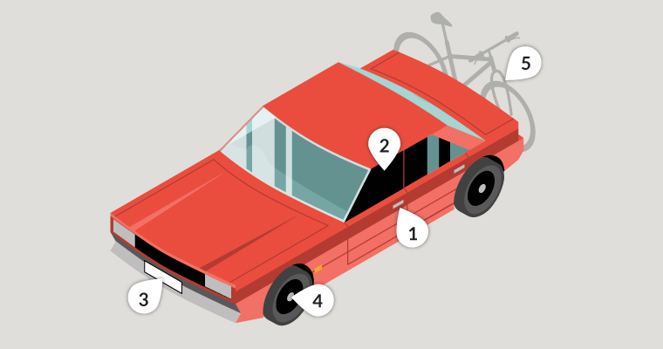

1. Always lock it
Fuelling up or popping back into your house to get something are perfect examples of how easy it is to turn your back for a moment and forget your vehicle is unsecured. So get into the habit of locking your vehicle even if you’re only going to be away from it for a moment.

2. Close windows and the sun roof to prevent ‘fishing’
Leaving windows and the sunroof open invites fishing for items through the gap by hand or with, say, a bent coat hanger, which could also be used to unlock a door for them to get in. Thieves can be ingenious. Don’t give them the opportunity.

3. Secure your number plates with tamper-resistant screws
The easiest way to change the identity of a stolen vehicle or avoid speeding tickets and parking tickets is to fit stolen number plates. Using security screws to attach your vehicle’s number plates makes it harder for thieves to get your number.

4. Fit locking, anti-tamper wheel nuts to secure alloy wheels
Stolen wheels are valuable, either as parts or for their scrap value. Using locking wheel nuts reduces the risk of your vehicle’s wheels being stolen.

5. Secure anything that’s on the outside of your vehicle
Anything left on roof-racks, tailgate racks, holiday top boxes or in tool chests are easily stolen when the vehicle is parked. The use of cable locks, padlocks and self-locking tools chests, which are secured to the vehicle, makes them more secure, but still, don’t leave things in them if you can avoid it. For further information and advice, visit Sold Secure.
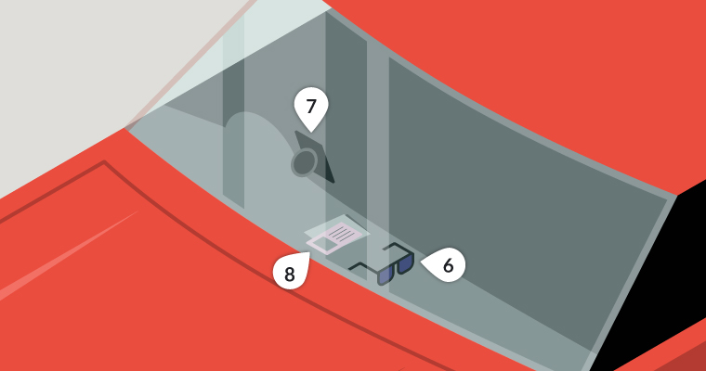

6. Take it with you or hide it
Your mobile phone, coins for the car park, sunglasses, packs of medication or other items that can earn quick cash are irresistible to the opportunist thief. Remember, the cost of replacing a window is often much more than that of what’s stolen. And it should go without saying that wallets, handbags, purses and credit cards should never be left in an unattended vehicle.

7. Hide electrical items and leave no clues
Leaving sat nav mounts, suction cup marks on windows or cables on view gives it away that you have left a Sat Nav, smartphone or other device in your car. Even if they can’t see the Sat Nav or iPad they might still break in to see if it’s stored in the car, out of sight.

8. Take your documents with you
Having a vehicle’s registration and insurance documents could let a thief pretend to be the owner. Which means they could sell it on quite easily. So, never leave any documents in the vehicle.
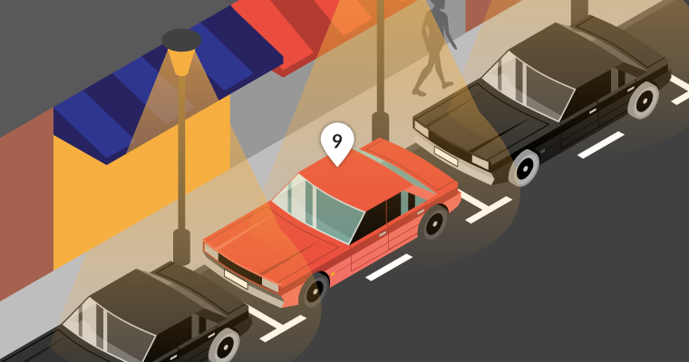

9. Park in well-lit and busier areas
It can take less than 30 seconds to break into a vehicle. Parking in well-lit areas and busy streets increases the chances of a thief being seen, so they’ll probably steer clear.

10. Choose your car park wisely
If possible, always try to park in well-lit and staffed car parks or those with a Park Mark safer parking award. To find one, simply check out Park Mark.

Catalytic converter theft
The precious metal in catalytic converters has led to an increase in their theft. To keep yours safe, ask your car dealer if they can give you any advice on locks or guards that are approved by the vehicle manufacturer.
Alternatively, try to make sure your vehicle is parked in a garage overnight, or if you have a commercial vehicle park it in a secure compound. If this isn’t possible, park in an area that’s well-lit and overlooked and try to park so that the convertor can’t be easily reached by potential thieves. Vehicles that sit high above the road are particularly vulnerable.
You should also register your converter and mark it with a forensic marker, which will make it harder for thieves to dispose of. Visit securedbydesign.com for more details.

