
Dear All
The following is the Manager’s Report for General Meeting, which is scheduled to take place on Tuesday 16th June and any further updates received will be provided at the meeting.
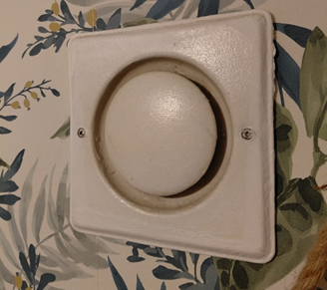
www.gouldenhouse.org/ventilation-scheme/
Section 20 Major Works (Extractor Fans) – I can confirm that I received the following update from WBC (Peter Roberts) on Tuesday 2nd June.
“Official
Good afternoon, Annie,
I am well thank you and hope you are also. Currently the section 20 Notice/ballot paper is in the final review process with legal and procurement. Once this has been finalised, letters will be sent to all residents in the coming weeks. I have no further updates or information to share at this stage
Kind regards Peter Roberts, Head of Heating Services Resident Services, Serving Richmond, and Wandsworth Councils.”
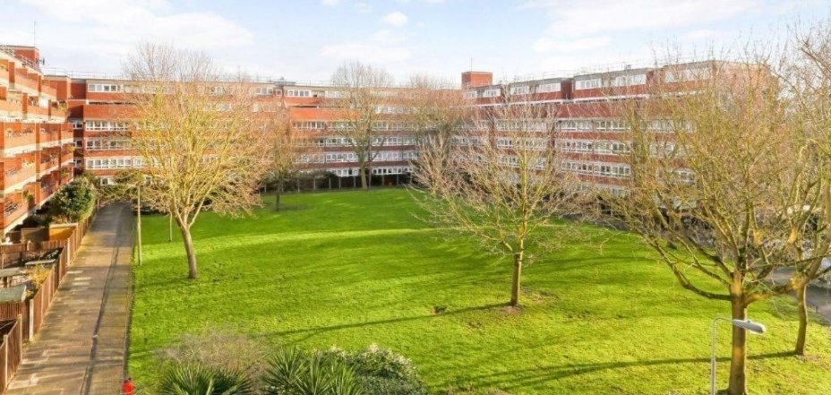
Section 20 Major Works (External Decs/Replacement of Windows) – The Notice of Intention (NOI) has been issued and the Consultation Meetings took place on Thursday 5th February between 4.30 pm and 7 pm. https://www.gouldenhouse.org/useful-information/window-replacement/ I sent a chaser email to WBC on Tuesday 2nd June and at the time of typing this report, I had not received a response. If I receive the response by the GM, I will of course provide you with an update at the meeting.

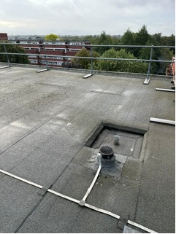
C1 Referral/Flat Roof – A C1 referral for Section 20 Major Works is an internal, localised administrative process used by specific UK housing co-operatives and Local Authorities. It is the formal submission or "referral" of a repair or major improvement project, like roof renewals etc to the landlord for the purpose of programming a Section 20 Major Works. At the Management Committee on 6th May, the decision was made to submit a C1 Referral pertaining to the Flat Roof. The Flat Roof is out of warranty and the Management Committee agreed that the Flat Roof should be at least programmed (Section 20 Major Works), it may not happen for a period of years, but the site is being cautious, i.e. better to have it programmed than not. The works to the Flat Roof will only be undertaken when they are necessary and until such time that they are deemed necessary, residents will be able to defer these works, similar process to that of the Intercoms, decisions on deferments will be made annually at the AGM.
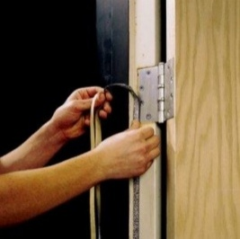
Health, Safety, Fire & Smoke Regulations/Non-Compliance (Flat Doors)/:
Update on Flat Doors - The following is the status of the Flat Doors at Goulden House as of 2ND June 2026:
•243 lessee Flat Doors inspected, of which 19 were Partially compliant
•Included with the 243 Flat Doors inspected are the 41 Social Housing Flat Doors which are fully compliant.
•26 Lessees provided no access; however, a letter is being compiled by the Officers of the Goulden House Management Committee, which will be sent to all remaining non-compliant flat door owners, WBC have been provided with this information.
Number of Flat Doors which remain non-compliant 26.
Number of Flat Doors which remain partially compliant 19.
In total 45 Flat Doors remain Non-Compliant or Partially Compliant, out of a total of 269 flats on the development. Non-Compliant Flat Doors is a serious breach of Health, Safety, Fire & Smoke Regulations, and a serious Breach of your lease. Please address your non-complaint Flat Door, the latter will protect you and your fellow neighbours.

Goulden House Co-Operative 5 Year Plan – The 5 Year Plan has been updated (June 2026) and has been uploaded to the GH website. Please use the following link:
https://www.gouldenhouse.org/wp-content/uploads/2026/06/5-Year-Plan-Goulden-House-Co-Operative-Ltd-2025-2030-Updated-in-June-2026-Working-Document.pdf
Pavements on Shuttleworth & Winders Road – Numerous engagements have been made with Wandsworth Borough Council pertaining to the condition of the pavements on Winders Road & Shuttleworth Road. A contractor’s report has also been provided to Wandsworth Borough Council pertaining to the condition of the pavements, the latter because of tree roots/ground movement. Further engagement was made with Wandsworth Borough Council’s Street Services Department upon the “strong recommendation” of WBC’s Tree Dept. on Tuesday 2nd June. The contractor’s report, images of the condition of the pavements were provided with the request for the “next steps” of when these pavements will be addressed. Any update from WBC will be provided at the meeting.
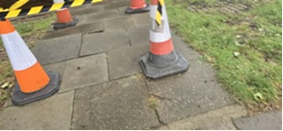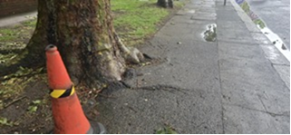
Pavement on Winders Road
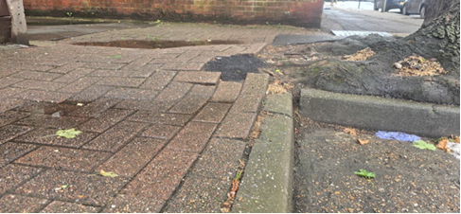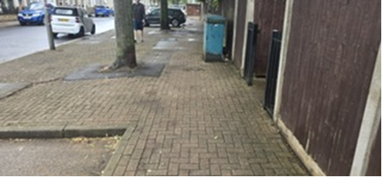
Pavement on Shuttleworth Road
Trees on the Inner Green – I also engaged with WBC Tree Dept. to request that a specific tree on the Inner Green was addressed, photos were provided and I received the following response on Tuesday 2nd June: “Official Thank you for sharing this with us, The images do not show touching the structure, can new pictures or better angle of it be shared? Please remember that it is not part of council policy to prune trees just because they are overhanging neighbouring property.
https://www.wandsworth.gov.uk/media/9792/tree_policy.pdf
Looking forward your response, Licida Parra Arboricultural Technical Support Officer”
You can also review Wandsworth Borough Council’s Tree Policy on the GH website via the following link: https://www.gouldenhouse.org/2026/03/wandsworth-tree-policy/
I can also advise that I have requested the most recent survey of the tress from WBC on Wednesday 3rd June and once received, it will be uploaded to the Goulden House website.
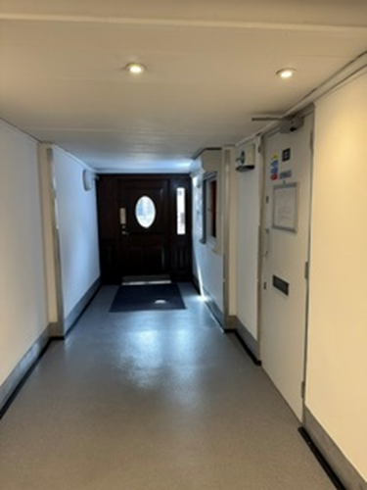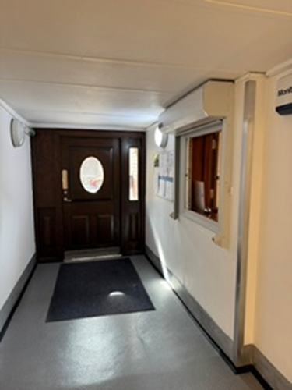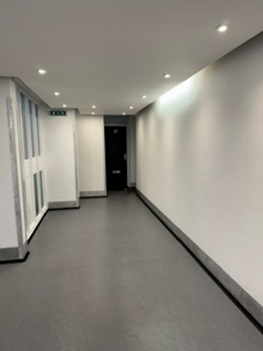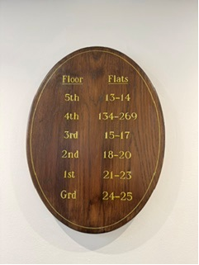
Main Entrance A Refurbishment Works – Main Entrance A (Phase 3 of the Refurbishment Works of the 3 Main Entrances), the refurbishment was completed in April, as per provision within the current fiscal year budget. The cost of the refurbishment works equated to £7,974 (Excluding VAT).
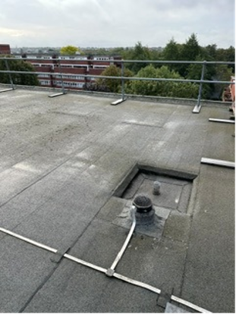
Annual Clearance of the Flat Roof – The Annual Clearance of the Flat Roof will be undertaken in July.

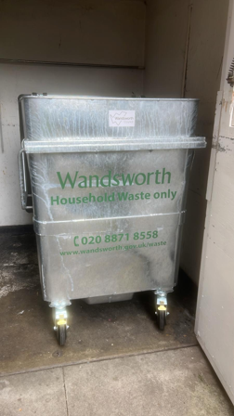
Paladins – I advised Wandsworth that several of the General Wate Paladins were defective/no longer fit for purpose, Wandsworth replaced 10 of the defective paladins recently.
UKSM – PAT test – PAT (Portable Appliance Testing), UKSM will undertake the Annual PAT testing on Monday 3rd August. The testing is undertaken within the Estate Office and Community Room on an annual basis.
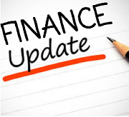
Finance Update – The update on Finance will be provided by the Treasurer at the GM on 16th June.

Audit – The Audit of the GH Accounts will be undertaken by Knox Cropper (Auditors) the week commencing 20th July.

Property Administration Assistant (New Post) – I can advise that interviews are scheduled to take place on Friday 12th June. I will provide you with an update at the GM on 16th June.
Goulden House Co-Operative Ltd Bullying & Harassment Policy Section 4 (a) – Goulden House Co-Operative Ltd operates a zero-tolerance approach to the mistreatment of staff by residents. Section 4 (a) of the policy states that formal warnings may be issued, where a resident’s conduct accounts to harassment or other inappropriate behaviour towards staff. Copies od such warnings are provided to Wandsworth Borough Council, in their capacity as Landlord, for audit trail purposes. Staff are employed to assist residents when they can legally do so, staff are not employed to be harassed or bullied. Ther Chair of the Goulden House Management Committee will discuss this further at the GM (16th June). You can review the policy via using the following link to the Goulden House Website:
https://www.gouldenhouse.org/wp-content/uploads/2026/06/Goulden-House-Co-Operative-Ltd-Bullying-Harrassment-Policy-Section-4-a.pdf

For and on behalf of Goulden House Co-Operative Ltd
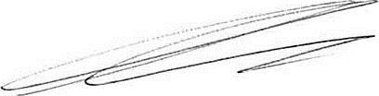
Annie Gleeson MSc
Estate Manager

