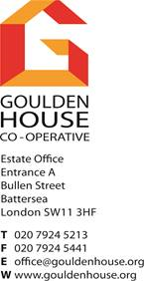

**NOTICE TO RESIDENTS - CAN UK LTD - INSPECTION OF THE STRUCTURE**

**COMMENCING WITH BLOCK C Sub-Entrances (OUTER GREEN) AT 8 AM TOMORROW (Tuesday 10th June) & moving round to main Block C**

As per letter dated 2nd June, from Wandsworth Borough Council, CAN UK Ltd (ABSEIL Team), will be commencing in Block C tomorrow morning (Tuesday 10th June) from 8 am until 5 pm. The work will generally include inspections and investigations of cracked and spalled areas of concrete to the external fabric of the building which were previously made safe in August 2023.

The works will run for approximately 4 working weeks with an anticipation completion date of 27th June 2025, the working hours will be 8.00am to 5.00pm Monday to Friday. **This will mean that operatives will be passing or suspended in front of your windows whilst they undertake works. With this said, I would encourage you to close your curtains/blinds/windows or make provisions to retain your privacy and security.**

Your assistance with the above is very much appreciated in advance.

For and on behalf of Goulden House Co-Operative Ltd

Goulden House Estate Office Staff