Goulden House Co-operative
Annual General Meeting
Virtual Meeting via Zoom (for access please turn over)
Community Room Entrance B
on Tuesday 8th December 2020 at 7:00 pm

AGENDA

1) Welcome to our virtual AGM meeting

2) Apologies

3) Minutes of the last AGM (22.07.19) corrections and approval (copies available from the Co-op office via email and on the GH website) (10 mins)

4) Approval of 2019/20 Audited accounts and update on tendering for new auditors (copies available from the Co-op office via email and on the GH website) (15 mins)

4) Manager's report (15 mins)

5) Major works, update from manager (15 mins)

6) Election of Management Committee members * (15 mins)

7) AOB (10 mins)

8) Date of next meeting (5 mins)

* In accordance with the Rules if you wish to join the Committee please complete and return the nomination and/or proxy form attached here to the Co-op office by close of business on 1st December 2020 at the latest.
Dear Resident,

This year’s AGM meeting will be held virtually using Zoom. In order for you to access the meeting we will provide Zoom URL Meeting Link, Meeting ID, and Passcode. Please see below for the options on how to access the meeting.

TO ACCESS THE AGM MEETING PLEASE USE ONE OF THE FOLLOWING OPTIONS:

OPTION 1. – URL Link
If you already have Zoom App installed on your phone for direct access to Zoom Meeting URL link using mobile devices (phone) please ensure you have downloaded an App for scanning barcodes and use your mobile phone camera to scan the code.

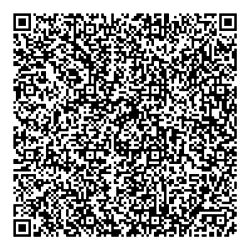
OPTION 2. – EMAIL
- For desktop computer and/or laptop access please scan the code below to obtain the meeting URL link and access codes via email.
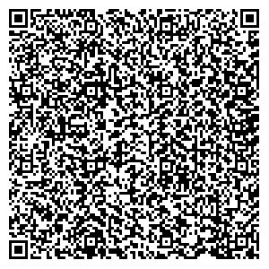

OPTION 3. – REQUEST THE MEETING CODES VIA EMAIL
If you are unable to use the above options please email GH-meetings@outlook.com and we’ll send you the link and access codes for the meeting. Please ensure you have the relevant information prior to minimum 24 hours before the meeting, as this email address will not be monitored once the meeting commences.

